Sustainability Impact analysis SpareBank 1 Østlandet 2022

2022
Summary 3
Background to the analysis 4
about the impact analysis 5
Step 1 About the business 6
Step 2 Sustainability parameters and national needs 6
Step 3 Impact 7
Retail Division – RM 8
Corporate Division - CM 10
Step 4 Results 11
Retail Division - RM 14
Corporate Division – CM 15
Conclusion and further action from the bank 17

Summary
In 2019, the UN Environment Programme for the Financial Sector (UNEP FI) launched the Principles for Responsible Banking (PRB). The purpose of the Principles is to ensure that the banking sector is driving force behind the UN Sustainable Development Goals and the objectives of the Paris Agreement. The Bank was a founding signatory and actively involved from the start. Part of the work on this initiative involved the development of an impact analysis that shows the banks where they have major positive and negative impacts on society. The Bank participated in the development of this tool and conducted its first analysis in 2020. The Bank was also involved in the work on a new version, which was launched in April 2021. This analysis is based on the 2021 version of the tool.
SpareBank 1 Østlandet only operates in Norway, so the analysis has been conducted for Norway. The Bank has previously carried out analyses that show we have the greatest impacts on society via our value chain, mainly through the services we offer to private individuals and businesses. This means we are talking about indirect impacts. In UNEP FI’s impact analysis, we analyse these via the Bank’s largest business areas: the Retail Division (RM) and the Corporate Division (CM). Lending is the Bank’s largest business area, supplemented by the provision of services via the RM. The analysis was based on figures from these business areas, as well as statistics for relevant sustainability topics for Norway.
The updated impact analysis highlights the following seven sustainability topics where the Bank has the greatest scope for positive and negative impacts: food, housing, work, resource utilisation, climate, waste, and inclusive, healthy economies. The impacts are spread across the business areas as shown in Figure 1.
In order to address the material topics arrived at by the analysis, we have adopted five strategic initiatives for this strategy period (2022-2025):
- Greener agriculture – CM
- Greener property – CM
- Greener property – RM
- Responsible consumption – RM
- Net zero greenhouse gas emissions by the end of 2050.
Figure 1 Results of the impact analysis

About the 2022 report:
This report is an updated version of the 2021 report. It has largely been updated with information about the guidance provided by the analysis in relation to our new strategy for 2022-2025. The analysis is the same as that carried out for the 2021 report.

Background for the analysis
SpareBank 1 Østlandet wants to contribute to the banking industry’s collective global sustainability work. The UN Environment Programme (UNEP) has a partnership with the financial sector called the Finance Initiative (UNEP FI). The Principles for Responsible Banking (PRB) were officially launched by UNEP FI in September 2019. Banks that sign up to the PRB commit themselves to complying with the six principles shown in Figure 1. The aim of the Principles is to ensure that banks around the world assume the role of being a driving force in the efforts to meet the UN Sustainable Development Goals and the commitments set out in the Paris Agreement.
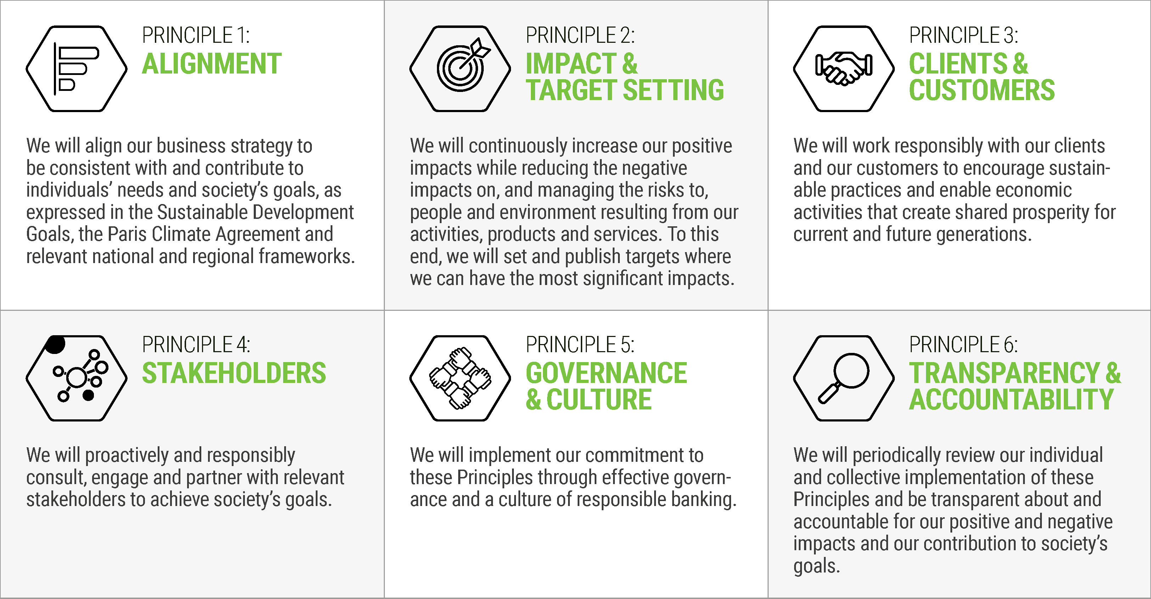
Figure 2: Overview of the Principles for Responsible Banking.
Principle 1 – Alignment: Banks must align their business strategy to be consistent with and contribute to individuals’ needs and society’s goals, as expressed in the Sustainable Development Goals, the Paris Climate Agreement and relevant national and regional frameworks.
Principle 2 – Impact and target setting: Banks must continuously increase their positive impacts while reducing the negative impacts on, and managing the risks to, people and environment resulting from their activities, products and services. To this end, banks must set and publish specific targets where they can have the most significant impacts.
Principle 3 – Clients and customers: Banks must work responsibly with their clients and their customers to encourage sustainable practices and enable economic activities that create shared prosperity for current and future generations.
Principle 4 – Stakeholders: Banks must proactively and responsibly consult, engage and partner with relevant stakeholders to achieve society’s goals.
Principle 5 – Governance and culture: To achieve their goals for responsible and sustainable banking operations, banks implement their commitment to these Principles through effective governance and a culture of responsible banking.
Principle 6 – Transparency and accountability: Banks must periodically review their individual and collective implementation of these Principles and be transparent about and accountable for their positive and negative impacts and their contribution to society’s goals.

About the impact analysis
The analysis shows where the Bank has positive and negative impacts in relation to various sustainability topics. In previous analyses, the Bank has found that we have the greatest impact on society via our value chain, mainly through the services we offer to private individuals and businesses in our market area. This means we are talking about indirect impacts. In UNEP FI’s impact analysis, we analyse the indirect impacts we have via the RM and the CM. Lending is the Bank’s largest business area, supplemented by the provision of services via the RM.
The Bank uses UNEP FI Portfolio Impact Analysis Tool For Banks - V 2.0 to conduct its analyses. This was developed in a collaboration between the member banks, and, as previously mentioned, SpareBank 1 Østlandet was involved in both the tool’s initial development and the tool’s revision. The analysis was based on the tool and integrated guidance. Generally, the analysis follows a series of steps, and this report is based on the same structure:
- About the business
- The first step of the analysis involves describing the Bank’s operations. This means its business areas, products, services and the geographical area to which they are linked.

- Sustainability topics and national needs
- In the second stage of the analysis, national needs are mapped according to the chosen geographical area. In our case, the tool maps Norway’s needs and challenges within the various sustainability topics.
- The tool has a total of 22 sustainability topics covering social, economic and environmental factors in the geographical area.

- Impacts
  - The analysis tool then generates an overview of positive and negative impacts based on the information provided in steps 1 and 2. This information is ranked based on criteria defined in the tool. It is recommended that topics in which the country performs poorly (relative to other countries) should be prioritised.
  - Next, the Bank’s impacts are assessed.

- Results
  - The tool generates an overview of material topics that should be prioritised in the sustainability work based on the needs in the country in which the Bank operates, the size of the portfolio and whether we are market leaders in this area.
The first time the analysis was conducted in the Bank, an internal working group was set up comprising representatives of Sustainability and Risk Management and analysts from the RM and the CM. SpareBank 1 Østlandet views the impact analysis as an important supplement to the materiality analysis. The impact analysis provides valuable insights into the Bank’s indirect positive and negative impacts on society, which enables us to better target our sustainability work.
Nevertheless, it is important to note the weaknesses of the analysis. It only provides an indication of the impacts that are typical for the relevant industries the Bank finances and the products we offer. In other words, it is not a direct mapping of the impact on our customers, rather it is a general overview of typical challenges related to industries and products in our market area. It thus provides an indication of the most important impact areas for each bank. It is not an exhaustive overview, which means there could be other topics where the banks have major positive and negative impacts, and which require attention, but which are not identified by the analysis.
The analysis therefore needs to be supplemented with other analyses, including good stakeholder engagement in the materiality analysis. It is also important to note that this mapping is done on a global basis. It draws on global sources which can on occasion be perceived as less relevant to Norway.

Step 1 About the business
In the first step of the analysis, banks are asked to enter information about their business. It is possible to analyse multiple business areas and different countries if the banks are global. SpareBank 1 Østlandet operates as a bank in Norway. Its market area is Eastern Norway and Innlandet County. Lending in the RM and the CM are the largest business areas, where the RM accounts for around 75 per cent and the CM around 25 per cent of the lending portfolio. Nevertheless, according to the Bank’s analyses, the CM is the area in which it could have the biggest impact. The RM and CM business areas were analysed. Internal data from the RM and the CM was supplemented with statistics from Statistics Norway (SSB).
For the CM, we looked at the main industries to which we lend money. The largest industries in the CM’s portfolio were entered, which represents 88 per cent of the lending portfolio. In the case of the RM, we analysed the services the Bank offers to customers. The Bank’s impact on sustainability in the market area was calculated based on this. We also entered information from Statistics Norway about low, medium and high income distribution among Norway’s population.

Step 2 Sustainability topics and national needs

The second step of the analysis involves ensuring that the sustainability topics shown in Table 1 have been input into the tool and adjusted for the countries the Bank operates in. The result from this part was that all of the topics were assigned a score from 1 (good) to 4 (poor). This part of the analysis shows that Norway has particular issues with resource utilisation (score 4) where particularly high energy consumption per capita is highlighted, and food (score 3) where the increase in obesity in the population is identified as a decisive factor.

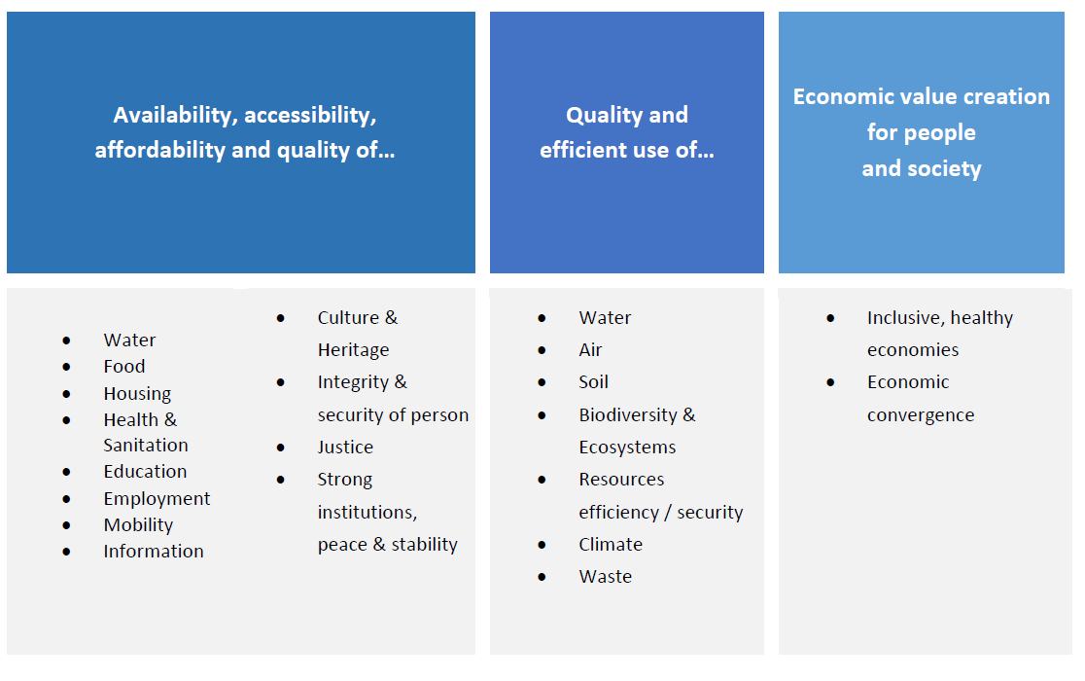
Table 1: Overview of the sustainability topics in the analysis

Step 3 Impact
After entering the figures from the RM and the CM into the analysis tool, it indicates on which sustainability topics the Bank has a positive and negative impact. Figures 2 and 3 show, for the RM and the CM respectively, where the Bank has the greatest scope for positive and negative impact on sustainability through its portfolio. The tool also generates an overview of the topics in which Norway has the greatest need to implement sustainability measures. In total, the information from this step of the analysis is intended to provide the basis for the subsequent steps of the analysis. The further the lines extend from the centre of the chart, the greater the Bank’s impact in this topic. LDCs are Least Developed Countries and the impact will be greater if the Bank does business in countries that have serious structural barriers to sustainable development. For the CM chart, the type of business is also entered to indicate the number of countries where the Bank contributes to an inclusive, healthy economy (as SpareBank 1 Østlandet only operates in Norway, this is set to 1).

Retail market – RM
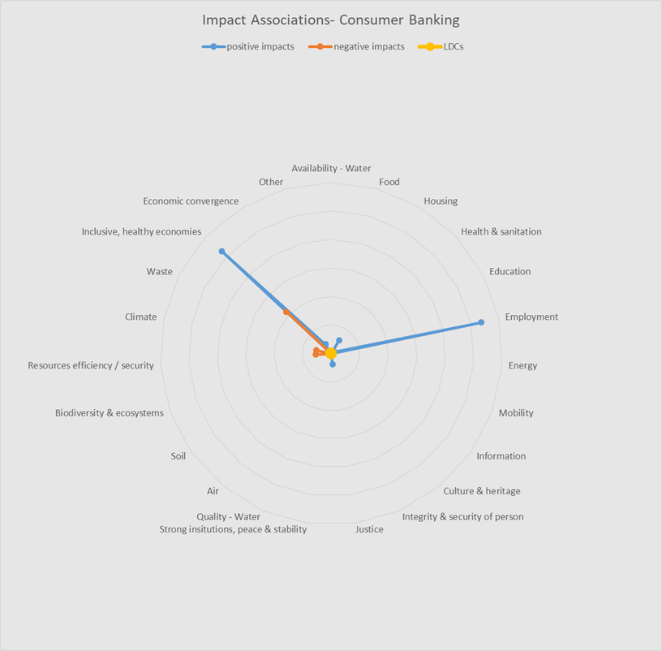
Figure 3: Positive and negative impacts on sustainability topics for the RM
As we can see from the RM’s product portfolio, it is the positive aspects that dominate. This is particularly true for the contributions made by the products to an ‘inclusive, healthy economies’ and ‘employment’. The analysis also identifies some negative impact in relation to how inclusive the products are, although it is clear from the figure that the negative impact is significantly lower than the positive impact.
The underlying factors that produce the negative and positive impacts from the RM’s product portfolio are shown in the overview in the figure below.

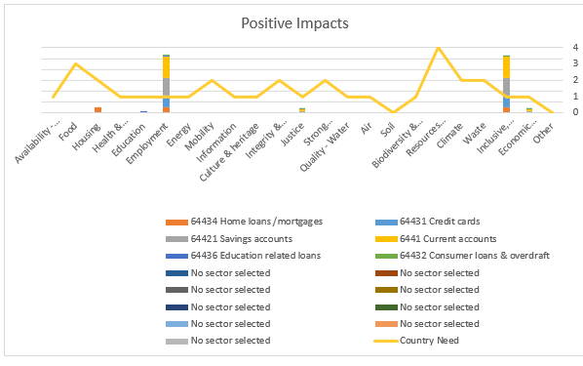
Figure 4: The columns indicate the positive impact of the colour coded products. The graph shows a country’s need for change within a sustainability topic, where 4 indicates the highest need and 0 indicates no need.

The figure above shows that it is the customers’ access to accounts such as current accounts and savings accounts that has the greatest positive impact. Access to credit facilities also has a positive impact. These make a positive contribution to the sustainability topics, ‘employment’ and an ‘inclusive, healthy economies’. While the impact of the Bank’s products is high here, the graph shows that the need for change in Norway is fairly low. The need for change in Norway is greater in relation to ‘housing’ and here the RM’s mortgages contribute to some extent to a positive change towards an inclusive housing market.
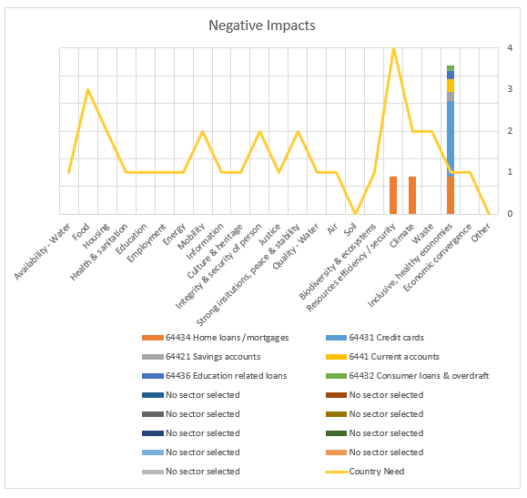
Figure 5: The columns indicate the negative impact of the colour coded products. The graph shows a country’s need for change within a sustainability topic, where 4 indicates the highest need and 0 indicates no need.
As far as negative impacts are concerned, the analysis shows that the Bank’s products can have an exclusionary effect. This depends on how large a proportion of the product portfolio is made up of customers with a low income.
The analysis does not go into further detail about why the various product categories have either a positive or a negative impact on the topic ‘inclusive, healthy economies’, just that this is a topic with ambiguities that we have to deal with. For other negative impacts, it is the impact of mortgages on ‘climate’ and ‘resources efficiency/security’ that are material topics that we must deal with. These will be a high priority for the sustainability work in Norway going forward.

Corporate Division – CM
An overview of the CM’s main impacts is shown below. As the figure suggests, the CM has a broader and more varied impact on various topics based on the different companies in the lending portfolio.
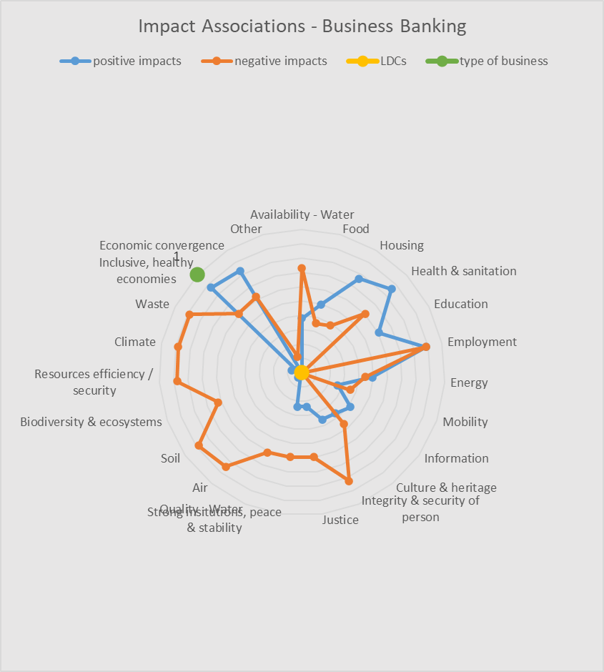
Figure 6: Positive and negative impacts on sustainability topics for the CM
According to the analysis, the big contributions to both the negative and positive impacts come from activities within commercial property, financial services, agriculture, property development and forestry.

Step 4 Results
Finally, the tool generates a list of results showing sustainability topics in which SpareBank 1 Østlandet has the potential to have major positive and negative impacts in its portfolio. We are then asked to prioritise based on the following considerations:
- Impact on topics that are most in need of change in Norway
- Impact on topics that account for a large proportion of the Bank’s portfolio
- Impact on topics where the Bank is a market leader

From these criteria, we derive seven sustainability topics where SpareBank 1 Østlandet can have the greatest indirect positive or negative impacts: food, housing, employment, resources efficiency/security, climate, waste and inclusive, healthy economies. Table 2 below provides more detailed information about what is included in the different areas. We first choose topics with great needs in Norway. ‘Resources efficiency/security’ is an example of such a topic, with a score of 4 (very high need). Other national needs have also been identified within ‘climate’, ‘waste’, ‘housing’ and ‘food’ (score 2), while ‘employment’ and ‘inclusive, healthy economies’ (score 1) have been prioritised on the basis of their prevalence in the Bank’s portfolio. This prioritisation can be seen in the descriptions in the table below.

 | Impact topic | SDGs | Description
Availability, affordability and quality of... | Food | 2 | Good availability of healthy food at affordable prices. Prevalence of malnutrition in the population. Prevalence of obesity in the population. Degree of food security.  Prioritisation: this topic is a priority due to its moderate proportion of the CM’s portfolio, primarily from agriculture, and fairly high needs score.
 | Housing | 3, 11 | Access to a sustainable housing market. Proportion of slum buildings, homeless people, costs related to the ownership and development of residential properties, population density of low income households.  Prioritisation: this topic is a priority due to the positive proportions in both the CM (high proportion) and the RM (lower proportion) and the need for change (score 2).
 | Employment | 8 | The population’s access to full and productive employment and decent work which provides a fair income, security in the workplace, social protection for families and entails opportunities for personal development and social integration. It also gives people the freedom to express their concerns, organise and participate in decisions that affect their lives, and get equal opportunities and fair treatment (ILO).  Prioritisation: employment has a low needs score (1), but is a priority because of its high proportions in both the RM and the CM.
Quality and efficient use of... | Resource efficiency/security | 6, 12, 13, 14, 15 | Efficient use of limited, non-renewable and renewable natural resources in the process of exploiting nature for production and consumption purposes. (UN Glossary, IRP).  Prioritisation: Both the RM (somewhat low proportion) and the CM (high proportion) score negatively on this and this is regarded as having the greatest need for change in Norway (4).
 | Climate | 13 | Further greenhouse gas emissions as a direct factor for anthropogenic climate change (IPCC).  Prioritisation: Both the RM (somewhat low proportion) and the CM (high proportion) score negatively on this and there is a need for change regarding this topic (2).
 | Waste | 6, 12, 14, 15 | Capacity to manage waste, including control, monitoring and regulation of production, collection, transport, treatment and disposal of waste, and prevention of waste generation through process modifications, reuse and recycling during a project lifecycle. This also includes waste reduction (UN Glossary, UNGA).  A high proportion of the CM’s portfolio scores negatively on this and there is a need for change regarding this topic (2).
Economic value creation for people and society | Inclusive, healthy economies | 8, 9 | Development and establishment of sustainable, diverse and innovative products that add value to society and the economy. This includes full and fair access for all social groups to labour markets, finance and entrepreneurship, and, more generally, economic opportunities. This includes but is not limited to, access to affordable, effective and secure financial services for individuals as well as small and medium-sized enterprises (UN DESA).  While the need for change is low (1), the CM and the RM score highly in relation to their positive impact on this topic, and the RM has some negative impact.
Table 2: In-depth information on the various sustainability topics on which the Bank has a major impact.
This gives us a priority list of three areas for both positive and negative impacts for both business areas, in line with Norway’s biggest sustainability challenges. This is shown more clearly in the table below for the RM and the CM:

Figure 7: Priorities for the RM and the CM

Retail Division – RM
For the RM, the results of the analysis were closely linked to the products and services we provide for housing and other purposes. The positive impacts in the RM were primarily linked to providing people with access to housing, either through products such as residential mortgages or by offering security deposit accounts. As far as the negative impacts in the RM are concerned, the results focus the mind on both greenhouse gas emissions linked to housing and on a more circular solution aimed at achieving more resource efficient homes in Norway going forward.
The RM has a material impact in relation to the topic of ‘inclusive healthy economies’: both the public sector and financial institutions have critical roles to play in driving forward inclusive, healthy economies. The public sector’s role includes providing a business-friendly environment and maintaining control and balance to ensure healthy competition. Financial products and services that meet the needs of entrepreneurs, SMEs, customers with low income, and women are vital for achieving diverse and healthy economies, as well as financial inclusion.
Policies addressing gender inequality and that aim for equal gender representation in institutions are equally vital for inclusive, healthy economies. Access to education and the provision of social services are crucial when it comes to addressing poverty and inequality.
Access to economic hubs/workplaces is also crucial in relation to inclusive, healthy economies. Efficient mobility, provided by transport systems and their associated infrastructure, is a key factor when it comes to providing access to the labour market and a healthy economy.
Access to information and communications technology has become both vital for a well-functioning economy and an important component for access to employment, information and the economy.
The RM’s financial services make positive contributions to the provision of these services and the creation of this dynamic in the Norwegian economy. However, challenges remain with respect to even better financial inclusion for segments that may currently be excluded to a greater or lesser extent.

Corporate Division – CM
The CM has several sustainability topics that are affected broadly as shown in the radar chart. The results here do not distinguish between sectors, rather they were intended to provide an overarching picture of what the analysis said the focus of our sustainability work should be on. The climate was important with respect to both positive and negative impacts. There must be, and currently is, a focus on reducing greenhouse gas emissions in the Bank’s portfolio. Furthermore, there must also be a focus on resource efficiency and transitioning to a circular economy mindset. We can see that the results in the CM were closely linked and were largely about thinking smart, using less resources, emitting less greenhouse gases and thereby also producing less waste.
For the negative impacts, the analysis clearly showed that a high proportion of the portfolio impacts important national needs such as better quality and efficient use of resources, as well as reductions in greenhouse gases and waste. These are the main impacts in relation to the CM’s lending portfolio that ought to be addressed going forward. The analysis tool provides further context for some of the negative impacts that may emerge from these categories:
Resource efficiency/security:
The production of biomass (wood, crops, livestock, fuel, raw materials and plant-based materials) requires a lot of resources and significantly contributes to water stress and land loss vis-á-vis biodiversity (IRP). Other drivers for this impact may be:
- Potential high energy and water consumption
- Energy consumption
- Use of energy, water, metals, minerals, chemicals, wood and land areas
Climate:
Energy, transport, manufacturing, construction, agriculture and real estate are the main sectors responsible for greenhouse gas emissions in the world today. The energy sector is the largest contributor to global greenhouse gas emissions. Energy-related volatile emissions include emissions of gases from exploration activities, production, processing, transport, storage and the use of fuels. The agricultural sector’s greenhouse gas emissions come from livestock farming (which releases methane), using fertilisers, deforestation (to create farmland) and emissions from soil (in connection with planting and cultivating crops). The emissions related to real estate are connected to the energy used to power buildings and the greenhouse gas emissions generated by the production, maintenance and disposal of a built asset (includes carbon emissions). This also includes emissions linked to the extraction, production, transport and assembly of each building material used to build an asset. Forests make a major contribution to carbon capture. Logging limits the amount of CO₂ emissions that could be captured had trees not been felled. Deforestation also releases remarkable amounts of greenhouse gases, which can be attributed to logging and land clearance, often for agricultural purposes.
Major drivers for this impact may be:
- Emissions of greenhouse gases linked to: production, consumers, machines, transport, warehouses, intensive agriculture, downstream heating, etc.
- Reduced CO2 capture capacity
Waste:
Globally, much larger quantities of industrial waste are generated than other hazardous waste like agricultural, construction and demolition waste, other waste that is hazardous to health, waste electrical and electronic equipment (WEEE) and municipal waste. Agricultural, construction and demolition waste are the second largest contributor (World Bank). Global food loss and food waste account for a significant proportion of food and green waste, and it is estimated that, globally, about 30 per cent of all food is lost or wasted (World Bank). These industrial activities generate toxic and/or non-biodegradable waste, which can permanently pollute water, soil and ecosystems, and cause serious health problems. Good examples of these are nuclear and biochemical waste. Another is plastic. Concern about technological waste containing both plastics and metals, including rare metals, is also growing. Other drivers of impact:
- Disposal of waste from: chemical containers, animal waste, processing waste, old machines and materials
- Packaging
- Waste management
- Waste generated by and in office facilities
On the positive associations, a number of factors come out very clearly, such as health and hygiene, housing, work, cultural heritage, education and an inclusive, healthy economy. One reason why they have a big impact may be that the industry code (NACE) analysis is done at a fairly crude level. This means that many impacts, both positive and negative, are ‘caught in the net’, even though the Bank does not necessarily finance all of the subcategories. This must be taken into account when the portfolio is investigated further. There is still reason to believe that housing should be included as a positive impact on the CM as well. This is because of the contribution from rentals, housing related to agriculture, and new projects that cover a need for housing in Norway. The CM’s focus on investments in agriculture is having a positive impact on the sustainability topic of food. The Bank is a major agricultural bank with customers across Eastern Norway, which is often called Norway’s pantry. Through its financing of these customers, the CM portfolio is making a positive contribution towards healthy Norwegian food and better food security for the country. The positive contribution to climate change also represents a significant contribution to cutting greenhouse gas emissions in Norway. The Bank is constantly working to reduce greenhouse gas emissions in its portfolio, and a number of strategic initiatives have been implemented to finance the green transition in the Norwegian business sector. This, as well as how we address the Bank’s other impacts, is discussed below.

Conclusion and further action by the Bank
The analysis provided us with important insights that we used to revise our sustainability strategy in 2022 as part of the process of developing a new general strategy for the Bank as a whole. In our new general strategy we have adopted sustainability as one of our four overarching goals. The goal is to ensure that ‘We are a clear driving force behind sustainable change.’ This entails a primary focus on how we can support our customers because our analyses show that we have the greatest impact in our value chain via the products and services we offer to our customers. In other words, we have the greatest indirect impact on society.
The topics that emerged from the impact analysis resulted in our adoption of the following five strategic initiatives for the coming strategy period (2022-2025):
- Greener agriculture – CM
- Greener property – CM
- Greener property – RM
- Responsible consumption – RM
- Net zero greenhouse gas emissions by the end of 2050
The Bank has a large agricultural portfolio and specialist agricultural advisers. Both the provision of general advice on agriculture and the focus on greener agriculture are important in reinforcing the Bank’s positive impact on the food sector in Norway. Through this, we help to finance healthy and cost-effective food for the Norwegian population, as well as a good and safe working environment for the farmer who produces the food.
The Bank also has large real estate portfolios, both for residential properties (RM) and for commercial properties (CM). Our work in the property sector, including for greener property in both the RM and the CM, is helping to ensure a good housing market, through property rental and new housing projects in the CM, as well as mortgages in the RM.
Together with our commitment to responsible consumption, this is contributing to an inclusive, healthy economy where we have products that contribute to a housing market that is accessible for most people, as well as a well-functioning labour market.
Additionally, most of our work on net zero greenhouse gas emissions by the end of 2050 is targeted at our customers and their work towards zero emissions. We estimate the carbon intensity in all of our customer portfolios and have set specific targets for cuts based on the Science Based Target methods. We also have specific products and services that incentivise customers to cut emissions.
However, the analysis shows us some challenges related to our customers which we must carry forward into the work of operationalising the strategic initiatives. A greater focus on improved resource efficiency is very important for Norway’s role in a more sustainable world, and a large part of the portfolio for both the RM and the CM is linked to this issue. The same applies with respect to reductions in greenhouse gas emissions, where agriculture and property in particular are industries with high emission levels. If we are to realise the vision of a more circular-economy, zero-emission society, these are challenges that we must pay extra attention to in the future in collaboration with our customers.

https://www.unepfi.org/banking/bankingprinciples
https://www.unepfi.org/banking/bankingprinciples/resources-for-implementation/impact-analysis/
Version 2.0 of the Portfolio Impact Analysis Tool For Banks was developed in 2021 and used by the Bank in 2022. Version 3.0 was developed by UNEP FI PRB in summer 2022. In the Bank’s assessment, this would produce the same results for us as V2.0 and we have therefore stuck to this version.
https://impact.economist.com/sustainability/project/food-security-index/Index
Global impacts of extraction and processing by resource type, remaining economy and households and Material consumption trends per country income groups UN environment, IRP (2019). Global Resources Outlook summary business. Implications for business leaders. https://www.resourcepanel.org/reports/global-resources-outlook p.18-20
Food accounts for 44 per cent of global waste composition, followed by paper and plastic. Kaza, S., Yao, L.,Bhada-Tata, P., Van Woerden, F.(2018). What a waste 2.0. A global snapshot of solid waste management to 2050. Global waste composition. World Bank Group https://openknowledge.worldbank.org/handle/10986/30317 p.29.

